9% Revenue Growth in Q2 and 13% in H1 with 11% PAT Surge driving strong Performance
Specialty Segment – 22% Share in Group Revenue in H1
Pune, India, Nov 5, 2025: Deepak Fertilisers and Petrochemicals Corporation Limited (BSE: 500645; NSE: DEEPAKFERT), one of India’s leading producers of industrial & mining chemicals and fertilisers (“DFPCL” or the “Company”), announced its results for the quarter ended Sep 30, 2025.
Consolidated Financial Highlights
H1 Operating Performance Trend (₹ Cr)
Q2 Operating Revenue Trend (₹ Cr)

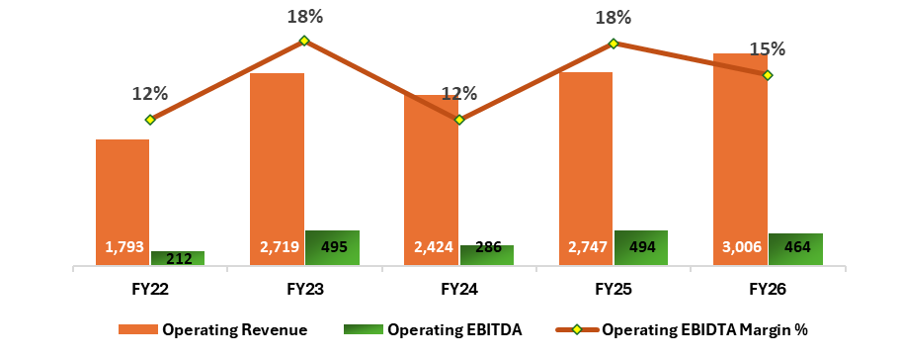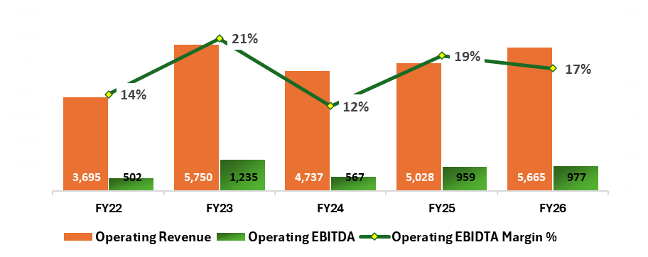
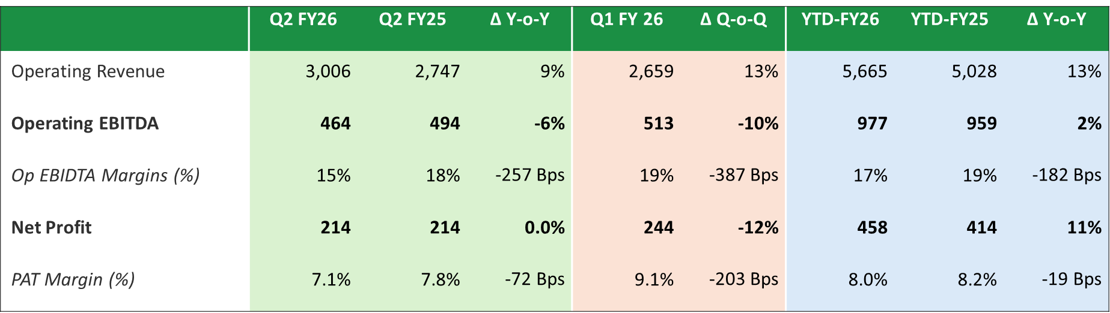
Key Highlights for Q2 & H1’FY26:
- Consolidated Revenues: Achieved a 9% YoY growth in operating revenues, driven by higher volumes in Croptek, TAN, and IPA. H1 revenue grew 13% YoY.
- EBITDA: Operating EBITDA down 6% QoQ to ₹464 Cr (vs ₹494 Cr), and H1 up 2% YoY to ₹977 Cr. Fertiliser business segment continues to outperform reflecting in the robust 36% YoY growth. While TAN continued its strong performance, IPA and Ammonia dragged the chemical segment which experienced a 21% YoY decline.
- Net Profit: Q2 PAT remained flat at ₹ 214 Cr while H1 PAT grew 11% YoY at ₹ 458 Cr
- Strategic Shift: Continuing on our transformative journey, the specialty products now make up 28% of CNB's revenue in Q2-FY26. Croptek volumes surged by 54% YoY, and the B2C segment contributed 14% to Mining Chemicals revenue.
- Net Debt: Despite a Capex spend of ₹870 Cr in H1-FY26, net debt rose by only ₹97 Cr, with a net debt to EBITDA ratio of 1.74x

Reflecting on the company’s performance, S.C. Mehta, Chairman and Managing Director of DFPCL, stated:


"Q2 FY26 reaffirms the strength of our strategic transformation and disciplined execution, anchored in our continued focus on specialty products, customer-centricity, and operational agility amidst evolving market dynamics.
Our Fertiliser and TAN businesses continue to deliver robust performance, driving strong growth in both revenue and margins. This resilience reflects the success of our differentiated offerings and deep engagement across core sectors.The Chemicals segment, however, was impacted by global headwinds, particularly in the IPA and Ammonia businesses, which saw a 21% YoY decline.
Our IPA business navigated a dynamic quarter shaped by global trade realignments and pricing volatility. A sharp correction in benzene and acetone prices, coupled with the impact of anti-dumping duties on China, led to increased US imports and margin pressure. Despite these temporary headwinds, we are actively repositioning for growth. With early signs of price stabilization and easing geopolitical tensions, we are confident in a near-term recovery. Our strategy—centered on expanding pharma-grade exports, driving cost efficiencies, and shaping a more level playing field through trade advocacy—is strengthening our competitiveness and positioning the IPA business for sustainable, profitable growth.
The Ammonia segment also faced a volatile quarter, with FOB Middle East prices averaging ~$300/MT and operational constraints adding to cost pressures. That said, the outlook is encouraging. Prices have rebounded above $400/MT, and a planned Q4 shutdown is expected to enhance capacity while delivering further NG savings. With the Equinor NG supply contract in place and operational efficiencies underway, we are well-positioned for a strong recovery in the coming quarters.
We also completed the full acquisition of Platinum Blasting Services (PBS), our Australian subsidiary, which delivered ₹533 crore in revenue and ₹80 crore in EBITDA in FY25. Acquired at an attractive 6.7x EBITDA multiple, this move strengthens our presence in the high-potential Australian mining market and reinforces our forward integration strategy. With this step, DMSL is poised to enhance its leadership in mining solutions across Australia and India.
Our strategic growth projects remain firmly on track, laying the foundation for the next phase of value creation.
We remain committed to delivering sustainable growth, backed by sharper execution, deeper customer engagement, and a clear focus on long-term value creation for all stakeholders.

Segmental Update

- Mining Chemicals (Technical Ammonium Nitrate):
Chemicals Review
- During Q2 FY26, overall sales volume increased by 29% YoY but decreased by 7% sequentially, reflecting the typical monsoon impact on coal demand.
- In the B2C segment, volume delivery grew by 33% YoY but declined by 17% QoQ, primarily due to reduced LDAN consumption at mines during the monsoon.
- Export volumes surged by 28% YoY, thanks to the easing of export license quota constraints in Q1 FY26. The export quota was increased to 50 KT per year in June 2025.
- Business Outlook: The third quarter is typically strong for mining and infrastructure demand post-monsoon. However, an extended monsoon may soften demand. Our focus will be on direct sales, regional warehouses, increasing export sales, and value pricing. With our high-quality, locally manufactured Technical Ammonium Nitrate, we will continue to play a key role in India’s growth story.
  - Pharma / Specialty Chemicals :
- Q2 IPA Sales: Sales volume rose by 2% YoY but declined by 6% QoQ. Domestic market sentiment remains weak due to sharp declines in Acetone prices and higher inventories of both Acetone & IPA.
- Building Block Nitric Acid: The business maintained its volume with a marginal drop of 3% YoY and 5% QoQ.
- Specialty Product - PICKBRITE: PICKBRITE delivered strong batch pickling results; bulk trial slated for Q3 FY26 with continuous line trials advancing. Trial volumes supplied to small-scale makers, more trials ahead. Cororid now in 250+ hospitals across 16 states.
- Business Outlook: The domestic market sentiment for Isopropyl Alcohol (IPA) remains subdued, primarily due to sharp declines in Acetone prices and elevated inventory levels of both Acetone and IPA. Additionally, Nitric Acid prices are expected to remain stable to slightly lower due to emerging excess availability from imports and new startups.
Despite these challenges, we have demonstrated resilience by intensifying our focus on market segmentation—strategically targeting customers based on application segments and proactively addressing their specific needs through innovation.
Crop Nutrition Business (Fertilisers) Review

- Q2 Croptek Sales: Sales volume surged by 54% YoY, driven by a sharpened focus on key crops such as sugarcane, soybean, arecanut, and cotton. This growth was further supported by strong farmer acceptance of the product’s value proposition. Overall manufactured bulk fertilizer volumes dropped by 31% YoY due to limited availability of critical raw materials and plant shutdowns.
- Specialty Fertilizer Business: Specialty fertilizers and Croptek contributed 28% to the fertilizer business revenue, up from 22% in the previous year.
- Crop-specific solutions like Croptek and Solutek, powered by targeted marketing and farmer engagement, drove strong impact—8,713 activities in Q2 reaching ~193K farmers through seminars, demos, and Saarthie meetings
- Business Outlook: Above-normal monsoon and strong reservoir levels set the stage for robust Rabi sowing, especially onion, sugarcane, and potato. With Croptek/Solutek traction and focused marketing, we expect a successful Rabi 2025

Project Update

- The Gopalpur TAN project is approximately 87% complete, and the Dahej Nitric Acid project is around 70% complete.
- Both projects, with a combined capex of ₹4,658 crore—Dahej (₹1,983 crore) and Gopalpur (₹2,675 crore)—are progressing as planned for commissioing by the end of FY26.
- All major statutory clearances required for construction are in place.
- All critical equipments are ordered and delivery in progress.
- Both plants are strategically located, taking care of raw material supply and offtake risks.

Company Overview

Deepak Fertilisers and Petrochemicals Corporation Ltd. (DFPCL) is among the India’s leading manufacturers of industrial chemicals and fertilisers. With a strong presence in Technical Ammonium Nitrate (mining chemicals), Industrial Chemicals and Crop Nutrition (fertilisers), the Company supports critical sectors of the economy such as infrastructure, mining, chemicals, pharmaceutical and agriculture. DFPCL is a publicly listed, multi-product Indian conglomerate and has plants located in four states, namely Maharashtra (Taloja), Gujarat (Daher), Andhra Pradesh (Srikakulam) and Haryana (Panipat).

DFPCL is Leading manufacturer and marketer of Iso Propyl Alcohol (IPA) in India and Largest Manufacturer of Nitric Acid in Southeast Asia. The Company is developing specialised grades of Nitric acid and IPA to meet specific requirements to cater needs of the industry/consumer.

DFPCL is one of the leading manufacturers of Technical Ammonium Nitrate in the world, it is the only producer of prilled Technical Grade Ammonium Nitrate solids and Medical Grade Ammonium Nitrate in India. The Company has commenced best in-class Technical Services to drive downstream productivity benefits for the mining end consumers.

In Crop Nutrition, DFPCL in past Seven years, has embarked on a transformative journey—evolving from a commodity-based business to a provider of differentiated and crop-specific solutions. This strategic shift is reflected in the development and deployment of innovative products such as Croptek, Smartek and Solutek, tailored for key crops including onion, cotton, sugarcane, corn, potato, soybean, tomato, grapes, pomegranate, and banana. Enhanced-efficiency fertilisers (NUE enhancer) are developed basis rigorous R&D efforts and bottom-up marketing focus supported by over ~95,000+ farmer demo plots over last 7 years. These efforts have shown distinct yield and quality improvements for crops across segments such as onion, cotton, sugarcane, corn, potato, soybean, tomato, grapes, pomegranate, and banana. Over last seven years, value-added nutrition products have benefitted 6 million farmers.

Deepak Fertilisers & Petrochemicals Corporation Ltd.
Reg. Off and Corp. Off: Sai Hira, Survey No. 93, Mundhra, Pune - 411 036
CIN: L24121MH1979PLC021360
www.dfpcl.com

Safe Harbour:
This document contains statements that contain “forward looking statements” including, but without limitation, statements relating to the implementation of strategic initiatives, and other statements relating Deepak Fertilisers and Petrochemicals Corporation limiter’s (DFPCL) future business developments and economic performance. While these forward looking statements are neither predictions nor guarantees of future events, circumstances or performance and are inherently subject to known and unknown risks and uncertainties, are based on management belief as well as assumptions made by and information currently available to management and only indicate our assessment and future expectations concerning the development of our business, a number of risks, uncertainties and other unknown factors could cause actual developments and results to differ materially from our expectations. These factors include, but are not limited to, general market, macro-economic, governmental and regulatory trends, movements in currency exchange and interest rates, competitive pressures, technological developments, changes in the financial conditions of third parties dealing with us, legislative developments, and other key factors that could affect our business and financial performance. DFPCL undertakes no obligation to publicly revise any forward-looking statements to reflect future / likely events or circumstances.

