FY25 PAT Leaps by 102%; Q4 PAT Jumps by 21%
Speciality Business Share Crosses 20%
Board Recommends 100% Dividend
Pune, India, May 22, 2025: Deepak Fertilisers and Petrochemicals Corporation Limited, one of India’s leading producers of industrial & mining chemicals and fertilisers, announced its results for the quarter and full year ended March 31, 2025.
Consolidated Financial Highlights
Full Year Operating Performance Trend (Rs. Cr)
Q4 Operating Performance Trend (Rs. Cr)
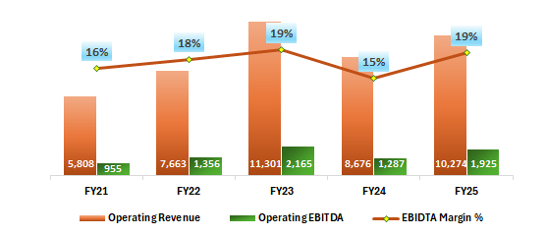
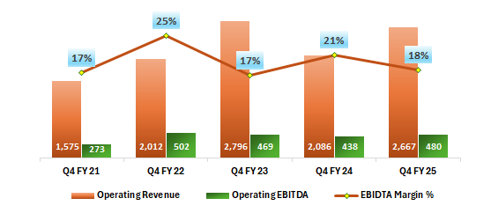

 | Q4 FY25 | Q4 FY24 | Y-o-Y Change | Q3 FY 25 | Q-o-Q Change | FY25 | FY24 | Y-o-Y Change
Operating Revenue | 2,667 | 2,086 | 28% | 2,579 | 3% | 10,274 | 8,676 | 18%
Operating EBITDA | 480 | 438 | 10% | 486 | -1% | 1,925 | 1,287 | 50%
EBIDTA Margins (%) | 18% | 21% | -299 Bps | 19% | -85 Bps | 19% | 15% | 390 Bps
Net Profit | 278 | 230 | 21% | 253 | 10% | 945 | 468 | 102%
PAT Margin (%) | 10% | 11% | -43 Bps | 10% | 46 Bps | 9% | 5% | 381 Bps

Key Highlights for Q4 FY25 & Full Year:
- Consolidated Revenues: The company demonstrated continued growth, achieving a notable 28% increase in revenues for the quarter, reaching Rs. 2,667 crores. Annual revenue growth stood at 18%.
- EBITDA: EBITDA for Q4 increased by 10%, amounting to Rs. 480 Cr. Full-year EBITDA experienced significant growth of 50%, reaching Rs. 1,925 Cr.
- Net Profit: An impressive 21% jump in Q4. Full year PAT doubled, amounting to Rs. 945 Cr.
- Strategic shift from Commodity to Specialty – Remarkable growth visible with revenue share from specialty products improving from 17% in FY24 to 22% in FY25.
- Growth Capex: Strategic investments remain on track – the overall progress in TAN project in Gopalpur is at 75%, and the same for Nitric Acid project in Dahej is at 48%.
- CNB business continue to out-perform - Bulk Fertilizers manufactured sales volume in Q4 surged by 68% YoY, driven by increased adoption of our innovative crop focus nutrient solution. During FY25, team achieved a significant milestone by surpassing 1 Million MT in bulk fertilizer sales and liquidation for the first time, demonstrating the team’s focus and effective execution of strategic products with scale.
- TAN Business – Our speciality product, LDAN, saw an impressive 11% YoY growth in sales volume in Q4FY25, and a notable 15% YoY increase for the entire fiscal year.
- Anti-Dumping Duty Implementation on IPA: USD 217 per metric ton ADD on IPA implemented in FY25 for a period of 5 years.
- Net Debt – Despite Capex spent of Rs. 655 Cr in FY25, net debt reduced from Rs. 3,426 Cr to Rs. 3,305 Cr based on healthy cash generation. Net debt to EBIDTA reduced from 2.66x to 1.72x on YoY basis.

Chairman’s Message

Reflecting on the company’s performance, S.C. Mehta, Chairman and Managing Director of DFPCL, stated:

This year has been challenging yet transformative, marked by strategic actions that boosted growth across all product segments. Our financial performance for FY 2024–25 highlights resilience, innovation, and a strong foundation for future success.
Key Strategic Factors:
- Transformation from Commodity to Specialty
Our shift from a commodity focus to a specialty and solutions-led company is well underway. Specialty products now comprise 22% of our total operating revenue, up from 17% in FY24, with a 51% YoY growth. Crop-focused fertilizers constitute 30% of our portfolio, reaffirming our commitment to delivering differentiated, customer-first solutions.
- Strategic Capital Projects for the Next Leap
FY 2025–26 is poised to be a pivotal year—one that will prepare us for a major operational leap, with key capacity expansions nearing completion by H2 FY26. These expansions will elevate us as one of the global leader in Technical Ammonium Nitrate and Building Block Nitric Acid. Riding on the INDIA GROWTH story of Mining, Infrastructure, Food security and Horticulture growth coupled with our 40+ years of experience, we are well positioned to unlock value across the businesses.
- Strengthening balance sheet
To ensure financial robustness, we raised ₹800 crore via CCDs in our subsidiary, DMSL, strengthening our balance sheet and addressing near-term funding needs while maintaining a prudent debt ratio.
- Organizational Restructuring for Agility and Growth
The year marked a key milestone with the restructuring of core businesses into three legal entities, enhancing focus, agility and growth amid challenges. By charting distinct growth pathways for each entity, we ensure alignment with overarching strategic goals while enabling operational autonomy.
- Innovation and R&D as Growth Catalysts
Innovation remains central to our strategy. Our focused R&D roadmap supports each business—advancing crop nutrition in CNB and driving productivity in Mining Solutions—fully aligned with our vision and customer needs.
Outlook:
With an above-average monsoon forecast, we expect robust Kharif season demand for crop-specific solutions. Mining Chemicals growth from FY25 is likely to continue into FY26, driven by increasing power demand and infrastructure investments. The health sector is projected to expand, supported by government and private initiatives, boosting our Pharma / Specialty Chemicals portfolio.

Chemicals Review

- Mining Chemicals (Technical Ammonium Nitrate):
- In Q4 FY25, overall sales volume grew by 13% QoQ and was marginally down by 3% YoY. We are currently close to full capacity utilization in our existing TAN plants and thus awaiting additional capacities of Gopalpur to meet increasing demand.
- Our premium product, LDAN, experienced a significant 11% YoY growth in sales volume for Q4 FY25, with a remarkable 15% YoY increase for the entire fiscal year.
    - Business Outlook: FY 25 witnessed a healthy growth of about 5% YoY in Coal mining to support strong demand for power and 5%-7% growth in Steel & Cement production, backed by increase demand in Infrastructure Sector. The trend is expected to continue in FY26. Increased explosives demand in Mining and Infrastructure sectors will have a positive impact on demand of our TAN products. TAN Business aims to remain integral to India's growth story, supporting key industries with reliable supply and innovative offerings.
  - Pharma / Specialty Chemicals :
- Q4 IPA sales volume declined 27% YoY & 31% QoQ, on account of shutdown taken to incorporate process improvement hardware to stretch the catalyst cycle length, improve productivity and reduce specific consumption of raw materials. The modifications were completed in Q4 and the plant is now fully operational. For FY25, the sales volume was down by 5% YoY.
- In contrast, Building Block Nitric Acid volumes demonstrated a robust performance, increasing by 29% YoY in Q4 FY25. In FY25, the volume grew modestly by 3% YoY
- Our Manufacturing efficiency drive based on benchmarking with the Global Best and Smart Factory Initiatives, has now established newer performance standards of Raw Material, Energy and Catalyst efficiency gains
- Business Outlook: The outlook for Nitric Acid indicates steady demand, supported by the strong requirements for Technical Ammonium Nitrate, even as demand from Nitroaromatics remains subdued. For IPA, while volume demand remains resilient, margins might face slight pressure due to weak market dynamics, driven by significant declines in Acetone prices and elevated inventories of both Acetone and IPA. Encouragingly, the specialty product portfolio continues to gain traction in the market, receiving positive acceptance from key customers.

Crop Nutrition Business (Fertilisers) Review
- In Q4 FY25, manufactured bulk fertilizer volume surged by 68% YoY. For the entire fiscal year, the growth was notable at 55% YoY and totalling 888 KMT, driven by above-normal monsoon rains in the operating region & acceptance of our innovative Crop Focus Solutions. Along with traded bulk, the company has achieved a significant milestone by surpassing 1 Million MT in bulk fertilizer sales and liquidation for the first time in a fiscal year, demonstrating the company’s focus and effective execution of strategic products with scale.
- The Innovative-Crop Specific Speciality product, Croptek, maintained its robust growth trajectory in Q4 FY25 with an exceptional growth rate of 111% compared to the same quarter of the previous year, propelling the CNB Vertical from a Commodity Fertilizer Business to a Speciality/Performance Fertilizer Business. Similarly, Smartek, another innovative product, delivered a strong performance in Q4 FY25, recording a YoY growth of 83%.
- Sale of specialty fertilizer Bensulf and water-soluble fertilizers in Q4 was up by 13% YoY and down by 19% QoQ. While sales of manufactured specialty fertilizer grew by 40% YoY, the traded specialty fertilizer volume remained at same level due to fluctuating output prices of vegetables and unseasonal rains damaged Grape crops which reduced consumption of WSF fertilizers.
- Business Outlook: India is likely to receive above normal rainfall during the upcoming monsoon. Considering our focus crops like Cotton, Soybean, Paddy and Corn for Kharif and with our strategy of Crop specific solutions & its salience, we expect continuing growth in market share in view of strong improvements in Crop Yields and Quality….thus helping build a Unique Brand “MAHADHAN”.

Project Update
- Construction ongoing at full fledge with overall progress of 75% in TAN Project & 48% in Building Block Nitric Acid Project at Dahej.
- All major statutory clearances required for construction are in place
- All critical equipments are ordered and delivery in progress
- Both plants are strategically located, taking care of raw material supply and offtake risks.

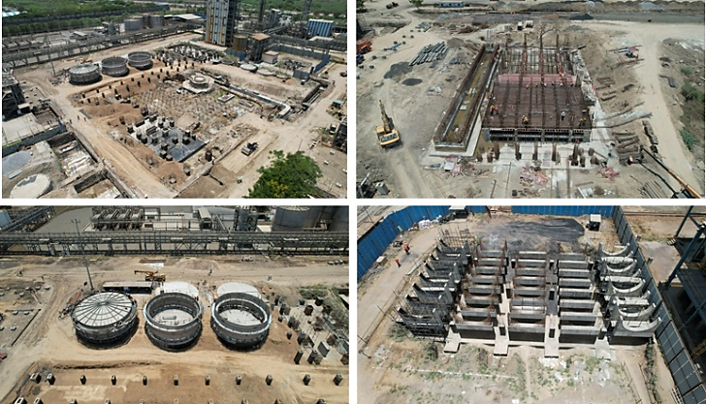
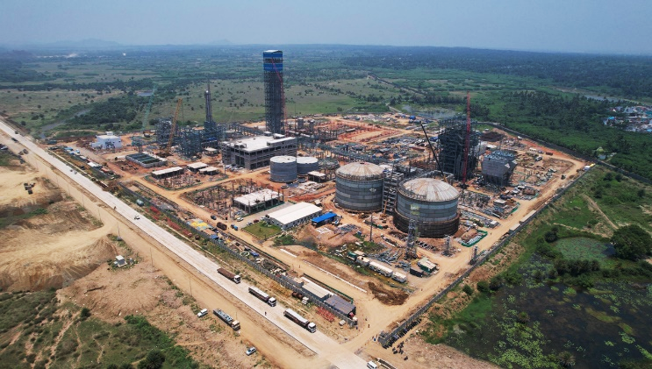
Nitric Acid Project - Dahej
TAN Project - Gopalpur

Company Overview

Deepak Fertilisers and Petrochemicals Corporation Ltd. (DFPCL) is among the India’s leading manufacturers of industrial chemicals and fertilisers. With a strong presence in Technical Ammonium Nitrate (mining chemicals), Industrial Chemicals and Crop Nutrition (fertilisers), the Company supports critical sectors of the economy such as infrastructure, mining, chemicals, pharmaceutical and agriculture. DFPCL is a publicly listed, multi-product Indian conglomerate and has plants located in four states, namely Maharashtra (Taloja), Gujarat (Daher), Andhra Pradesh (Srikakulam) and Haryana (Panipat).

DFPCL is Leading manufacturer and marketer of Iso Propyl Alcohol (IPA) in India and Largest Manufacturer of Nitric Acid in Southeast Asia. The Company is developing specialised grades of Nitric acid and IPA to meet specific requirements to cater needs of the industry/consumer.

DFPCL is one of the leading manufacturers of Technical Ammonium Nitrate in the world, it is the only producer of pilled Technical Grade Ammonium Nitrate solids and Medical Grade Ammonium Nitrate in India. The Company has commenced best in-class Technical Services to drive downstream productivity benefits for the mining end consumers.

CNB Segment (fertilisers) offers a basket of 48 products which include bulk fertilisers, Crop nutrient solutions, specialty fertilisers, water-soluble fertilisers, bio-stimulants, micro-nutrients, and secondary nutrients, catering to every crop’s nutrient requirement. Enhanced-efficiency speciality fertilisers are developed basis rigorous R&D efforts and product trials at over 50,000 farmer demo plots. The R&D efforts have shown distinct yield and quality improvements for crops across segments such as cotton, sugarcane, onion, fruits and vegetables. Over last three years, value-added nutrition products have benefitted 6 million farmers.

Deepak Fertilisers & Petrochemicals Corporation Ltd.
Reg. Off and Corp. Off: Sai Hira, Survey No. 93, Mundhra, Pune - 411 036
CIN: L24121MH1979PLC021360
www.dfpcl.com

Safe Harbour:
This document contains statements that contain “forward looking statements” including, but without limitation, statements relating to the implementation of strategic initiatives, and other statements relating Deepak Fertilisers and Petrochemicals Corporation limiter’s (DFPCL) future business developments and economic performance. While these forward looking statements are neither predictions nor guarantees of future events, circumstances or performance and are inherently subject to known and unknown risks and uncertainties, are based on management belief as well as assumptions made by and information currently available to management and only indicate our assessment and future expectations concerning the development of our business, a number of risks, uncertainties and other unknown factors could cause actual developments and results to differ materially from our expectations. These factors include, but are not limited to, general market, macro-economic, governmental and regulatory trends, movements in currency exchange and interest rates, competitive pressures, technological developments, changes in the financial conditions of third parties dealing with us, legislative developments, and other key factors that could affect our business and financial performance. DFPCL undertakes no obligation to publicly revise any forward-looking statements to reflect future / likely events or circumstances.

